1. **PURPOSE**

The purpose of this procedure is to describe the actions required to receive orders from customers and to ensure accuracy and completeness of the order entry process. This procedure will also describe the process necessary to confirm orders with customers as well as provide notification of orders to the contract manufacturer, IsoRay.

This procedure establishes the responsibilities of GT Medical and IsoRay, within the compliant process.

1. **SCOPE**

This procedure applies to all orders received by GT Medical Technologies (GT Med Tech) Customer Service. This procedure does not cover shipping products to customers, which is managed by IsoRay.

1. **REFERENCES**

* ISO 13485:2016 – “Medical devices -- Quality management systems -- Requirements for regulatory purposes”
* 21 CFR §820.160 – FDA Medical Device Quality System Final Rule, (Distribution)
* 21CFR §820.60 – Identification
* 21 CFR §820.65 – Traceability
* Health Insurance Portability and Accountability Act (HIPAA)
* SOP-001, Quality Manual

1. **DEFINITIONS**
   1. Designee: Personnel given responsibility for one or more aspects of order processing. Designees will be competent (through training or other means) to perform their responsibilities.
   2. Established Account: A facility that has a RAM license on file that has been approved by IsoRay’s Radiation Safety Officer (RSO).
   3. New Account: A facility that does not have a RAM license on file.
   4. Radioactive Materials License (RAM License): License required due to regulation of radioactive material as overseen by the U.S. Nuclear Regulatory Commission (NRC) under the Atomic Energy Act of 1954.
2. **RESPONSIBILITY**
   1. GT Med Tech Customer Service (Customer Service) is responsible for processing order data entry and ensuring order entry accuracy. Customer Service also manages customer communications.
   2. GT Med Tech Sales (Sales) is responsible for entering Customer Account and Contact information, updating Customer Opportunity information and uploading Customer provided documentation.
   3. The IsoRay RSO is responsible to verify that the customer’s RAM license is in place and correct for the amount of isotope to be shipped.
   4. IsoRay Customer Service is responsible for receiving orders from GT Med Tech Customer Service, analyzing requested delivery dates and providing expected delivery dates based upon manufacturing and shipping timing guidelines. IsoRay Customer Service will also provide GT Med Tech Customer Service order status and tracking updates via FedEx emails.
3. **PROCEDURE**
   1. **New Account Set Up**
      1. Sales personnel in charge of the Account will enter Customer Account and Contact information into Salesforce (contacts must include Facility RSO and Order Administrator). Once all information has been entered, Sales will change the status of the Account Opportunity in Salesforce to “Converted to Customer”. With this change, Salesforce will automatically send an email to Customer Service to notify them to review Account and Contact data. Orders may not be shipped to a facility until complete Account data has been entered and a RAM License, Sales Tax Exemption Certificate and Pricing Agreement (or acceptable Pricing Terms) have been received/entered into Salesforce and reviewed and approved by Customer Service and IsoRay.
         1. Upon review of Account and Contact data, if Customer Service deems that Account data is complete, Customer Service will update account status to “GTMT Internal Review Complete” and, for the Limited Market Release customers, click the LMR checkbox. If data is not complete, Customer Service will notify Sales.
         2. Upon document/pricing terms review and approval, Customer Service will mark the Sales Tax Exemption Certificate approval field and the Pricing Agreement (if applicable) and Contract Pricing approval fields in the Document Review section of the account.

* + 1. After a RAM license has been received by Customer Service, Customer Service will enter data into the License Record section in Salesforce, and a notification will automatically be sent by Salesforce to the IsoRay RSO to login to Salesforce and review and update the status of the RAM License to approved.
       1. Upon RSO approval, an automated email will be sent to Customer Service and Customer Service will mark the RAM License Reviewed checkbox in the Document Review section of the account.
       2. If the license is not approved, the RSO will contact Customer Service and Customer Service will contact Sales to notify them that an order may not be shipped until the license is approved.
    2. Once all approvals are received/documented in Salesforce, Customer Service will set up Salesforce Community Users, as needed, using Appendix E “Salesforce New User Instructions”.
    3. Once the first order has been received, Customer Service will change the Customer Status to “Active” and add the date of the first order to First Order Date field on the account.
    4. Monthly, Customer Service will run reports on RAM License approval, Pricing Agreement/Term approval, and First Order received date and provide data to Accounting for related Third-Party Sales New Account Milestone payments.
  1. **Established Accounts**
     1. Customer Orders are submitted by Customers using the Hospital Community in Salesforce. Order submission will create an order number. The order will have a status of “Submitted” and Salesforce will send an automated notification email to GT Med Tech Customer Service.
        1. Customer Service will review each order and if information is missing or unclear, will contact the customer for clarification. If order information needs to be edited, either the Customer or Customer Service can edit order details.
        2. After the order has determined to be correct, Customer Service will change the Order Status to Order Accepted. With this change, Salesforce will automatically send a notification email to IsoRay Customer Service.
        3. Once the order is reviewed and entered into IsoRay’s system, IsoRay Customer Service will Login to Salesforce and enter the IsoRay Order Number and Expected Delivery Date and change the order status to Vendor Confirmed. With this change, Salesforce will send two automated emails – one to GT Med Tech Customer Service and another to the Customer.
           1. If the Expected Delivery Date does not meet the Requested Delivery Date, IsoRay will notify GT Med Tech Customer Service via email prior to entering details into Salesforce. GT Med Tech Customer Service can then contact the customer to discuss the Delivery Date difference and determine if the order will still be placed.
           2. Once the status has been changed to Vendor Confirmed, Order details can no longer be updated by a customer or by GT Med Tech Customer Service. Only a GT Med Tech Super User can make these changes, and changes will need to be accompanied by communication with and agreement from IsoRay Customer Service.
        4. When the order has been manufactured and shipped to the Sterilizer, IsoRay Customer Service will send an email confirmation to GT Med Tech Customer Service. This email will automatically update the order record in Salesforce with the tracking number and will update the Order Status to “Shipped to Sterilizer”. With this status change, Salesforce will send two automated emails – one to GT Med Tech Customer Service and another to the Customer.
        5. When the order has been sterilized and shipped to the Customer, IsoRay Customer Service will send an email confirmation to GT Med Tech Customer Service. This email will automatically update the order record in Salesforce with the tracking number and the Scheduled Delivery Date and will update the Order Status to “Sterilized” if the Scheduled Delivery Date is not later than the Expected Delivery Date. With this status change, Salesforce will send two automated emails – one to GT Med Tech Customer Service and another to the Customer.
           1. If the Scheduled Delivery Date is later than the Expected Delivery Date, Salesforce will update the Order Status to “GTMT Internal Review” and send an automated email to GT Med Tech Customer Service. GT Med Tech Customer Service will then reach out to the Customer to understand if the change in date is acceptable or if the order should be cancelled. If the change is acceptable, GT Med Tech Customer Service will change the Order Status to “Sterilized” and Salesforce will send two automated emails – one to GT Med Tech Customer Service and another to the Customer. If the order needs to be cancelled, GT Med Tech Customer Service will change the order status to “Cancelled – Before Delivery” and notify IsoRay. With this change, a cancellation email will be automatically sent to the Customer.
        6. When the order has been delivered, the Order Status will be automatically updated via a FedEx Integration. With this status change, Salesforce will send two automated emails – one to GT Med Tech Customer Service and another to the Customer.
  2. In addition to monitoring email notifications, accounts, contacts, orders and requests submitted by accounts through Salesforce will be monitored by GT Med Tech Customer Service via regular review of activity (and lack of activity) related and status change reports.

1. **Order Cancellation**
   1. GT Med Tech Customer Service shall notify IsoRay Customer Service of all order cancellations via email. If an order has shipped, the Customer can either refuse the delivery or return the shipment.
   2. Cancellations may result in a $2500 Cancellation fee to Customers.
   3. GT Med Tech Customer Service will change the order status in Salesforce to “Cancelled – Before Delivery” or “Cancelled – After Delivery”, as appropriate, and identify the applicable cancellation reason. Selection of this status will prompt an automated email to the customer via email.
   4. GT Med Tech Customer Service will email Accounting to cancel the PO if the order has not yet been produced.
2. **Customer License nearing Expiration**
   1. Salesforce automatically sends reminder emails regarding upcoming license expiration to the account’s active RSO and GT Med Tech Customer Service 120, 90, 60 and 30 days prior to the license expiration date. If an email is entered with an expiration date prior to 30 days, reminder emails are also automatically sent from Salesforce.
   2. The Account, GT Med Tech Customer Service or Sales can upload the copy of the new license file to the account (using the document type “RAM License”).
   3. GT Med Tech Customer Service will receive an automated email from Salesforce upon license upload and will then review and add or update the license data within Salesforce. A new license record should be added only if the license number changes. Updating data will set the RAM License Category field in Salesforce to “None”. Once new license data is added, or data is updated, an automated email is sent from Salesforce to IsoRay Customer Service to review and approve the RAM License.
   4. GT Med Tech Customer Service shall regularly run reports of expiring licenses and review these reports with Sales.
3. **QUALITY RECORDS** 
   1. The following order information must be retained:

* GT Med Tech Order number
* IsoRay Order number
  1. FDA requests: If FDA verbally requests additional information, GT Medical’s Quality Representative or delegate shall ask to follow up such requests in writing.
  2. Retention: Retention times for customer and order files must be in accordance with Document and Record Controls procedure as per SOP-001, Quality Manual.

1. **APPENDICES**
   1. Appendix A: Customer Set Up Flowchart
   2. Appendix B: Order Management Flowchart
   3. Appendix C: Customer Nearing License Expiration Flowchart
   4. Appendix D: Step-by-step Salesforce Instructions
   5. Appendix E: Salesforce New User Set Up Instructions
2. **DOCUMENT HISTORY**

|  |  |
| --- | --- |
| Functional Area | Signature & Date |
| Operations |  |
| Quality |  |
| Regulatory |  |

|  |  |  |
| --- | --- | --- |
| **REVISION HISTORY** | | |
| Rev. # | Released Date  (YYYY-MM-DD) | Author |
| 1 | 2018-10-10 | Anne Brazeal |
| 2 | 2018-11-26 | Raines DeMint |

**APPENDIX A – Customer Set Up Flowchart**

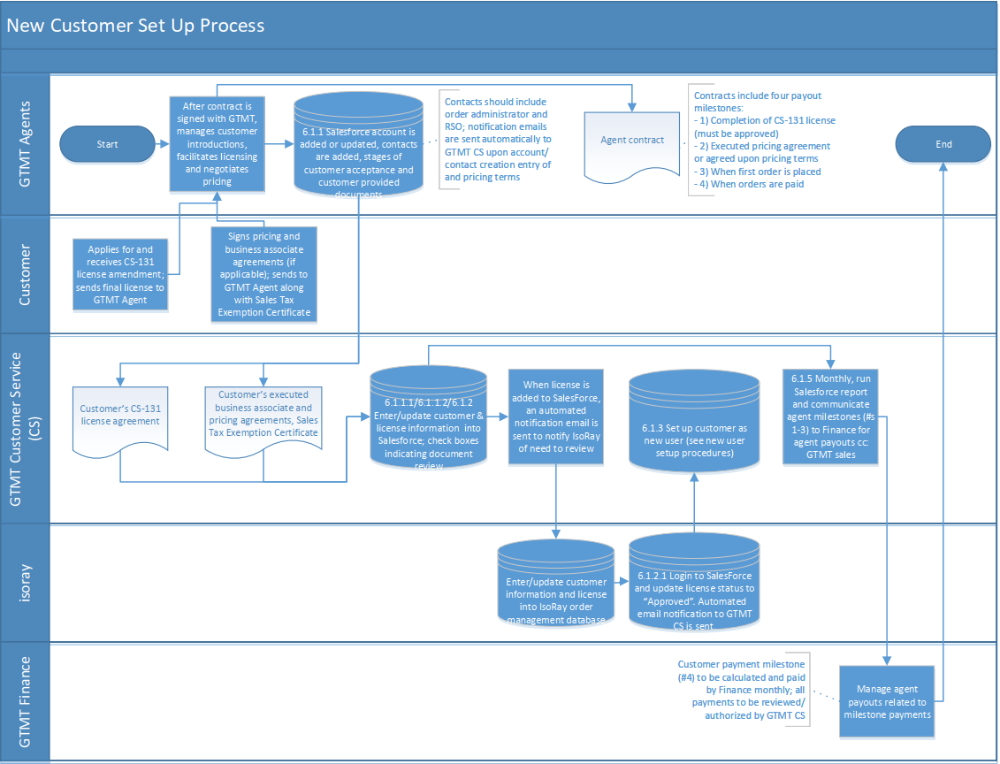

**APPENDIX B – Order Management Flowchart**

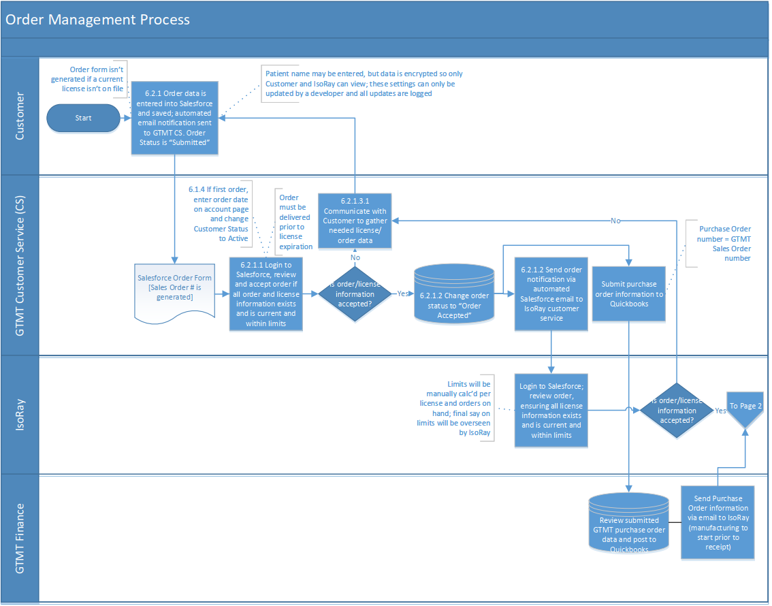

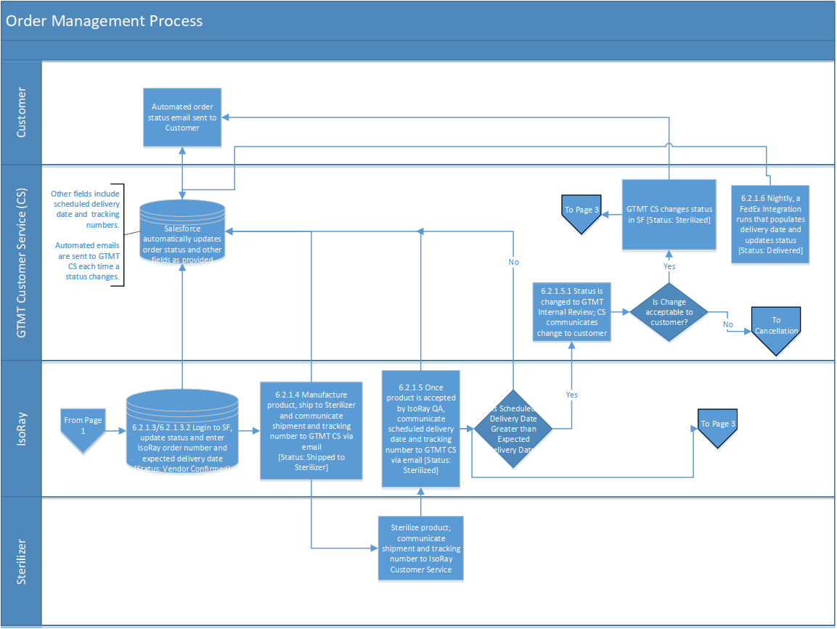

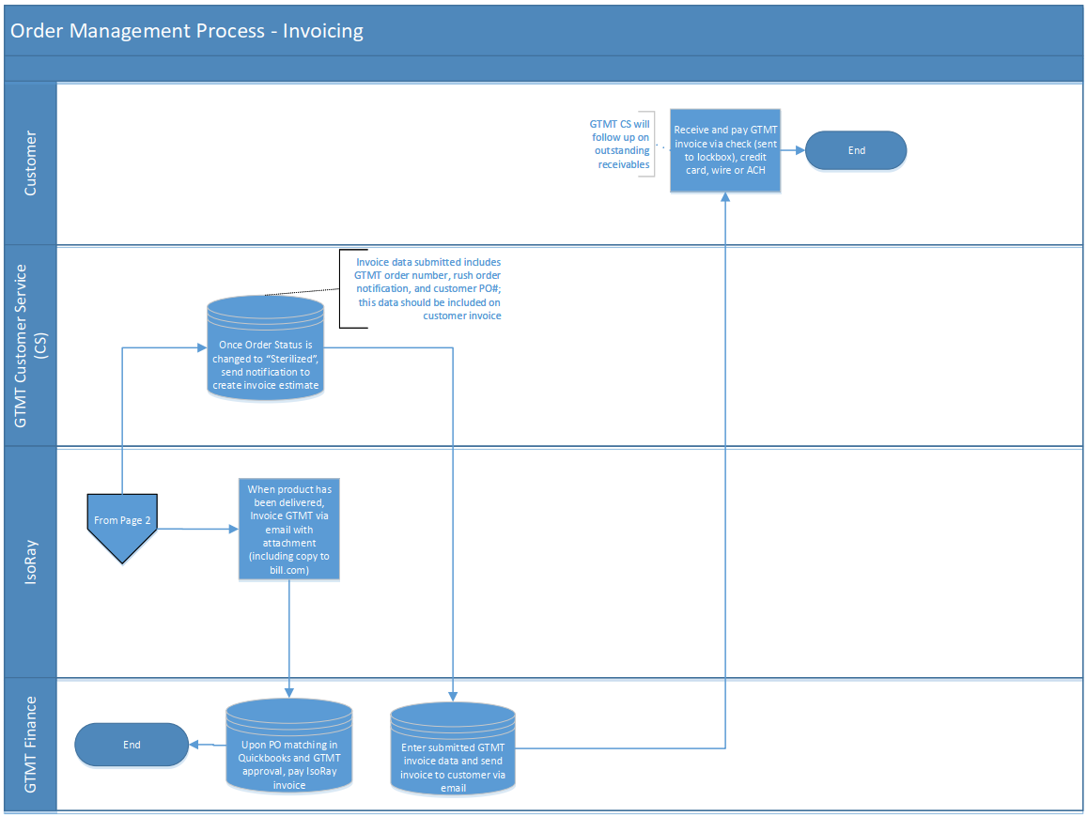

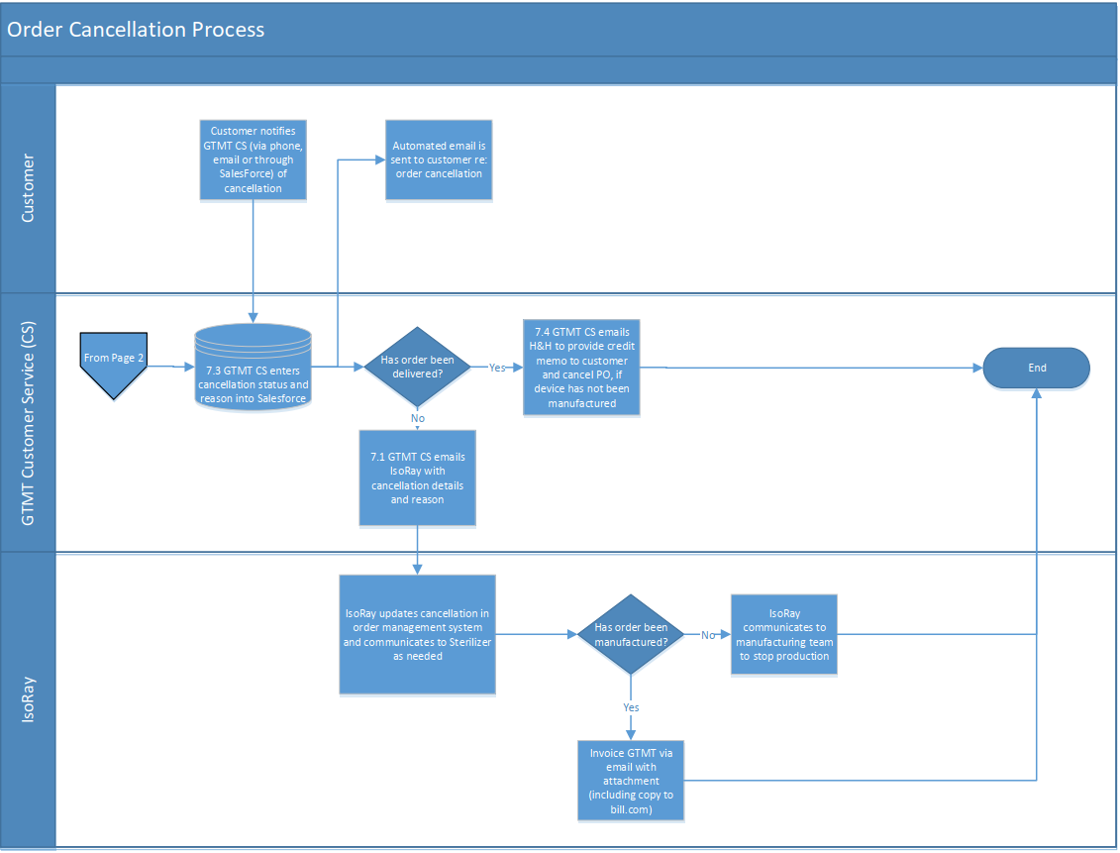

**APPENDIX C – Customer Nearing License Expiration Flowchart**

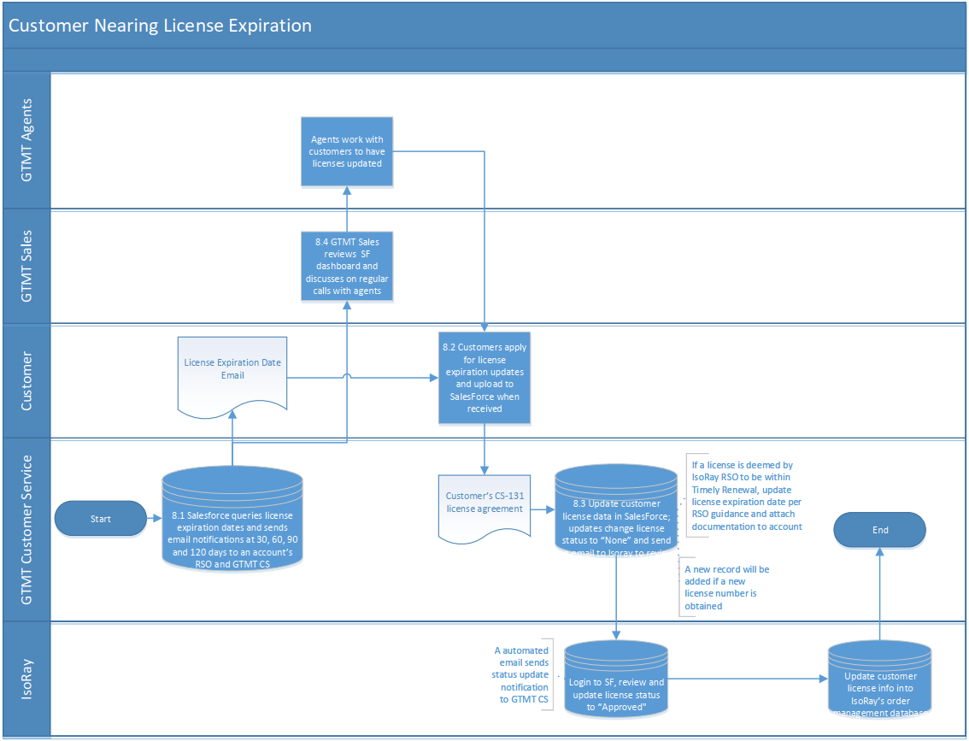

**APPENDIX D – Step-by-step Salesforce Instructions**

1. **Accounts/Contacts**
   1. **New Account Set Up**

**After logging into Salesforce and clicking Accounts and click New:**

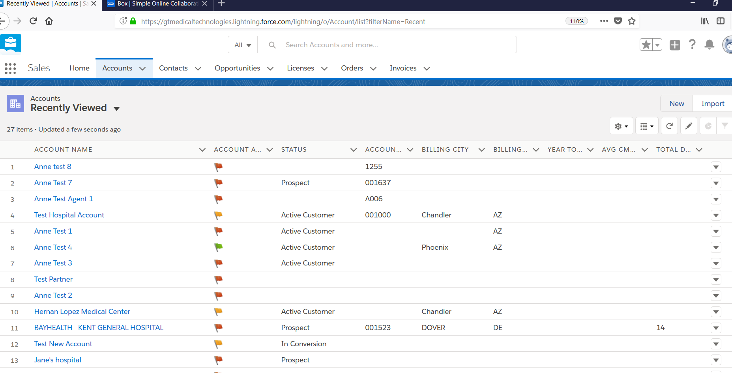

**Select the appropriate account type and click Next:**

`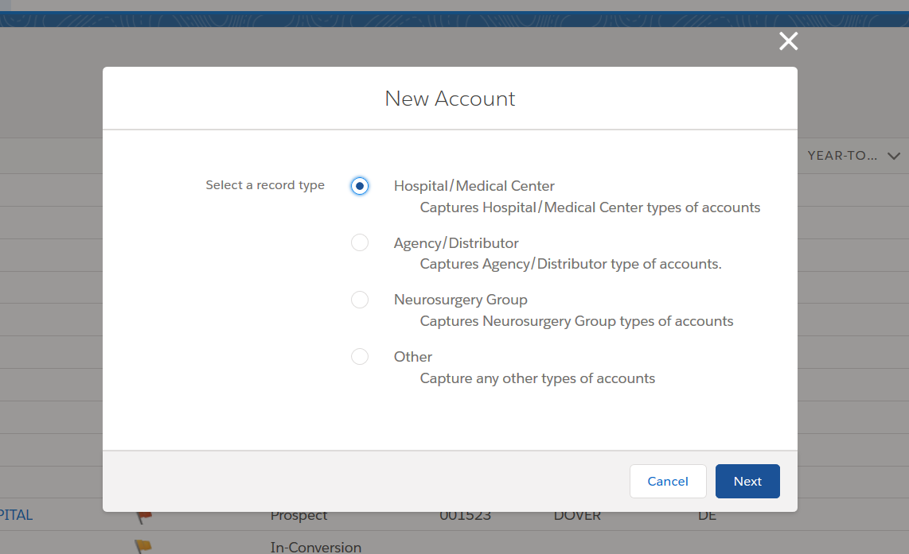

**Enter all new account information and click Save:**

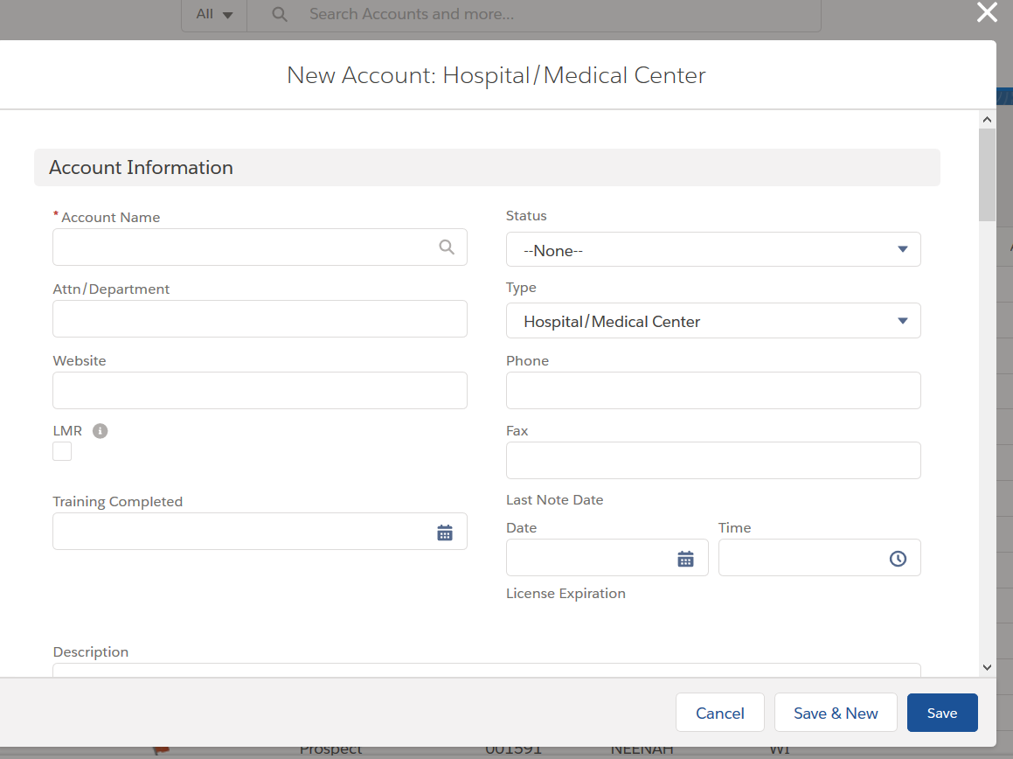

* + 1. **License Data Entry**

**On the Account main page, click the Licenses tab below the status bar:**

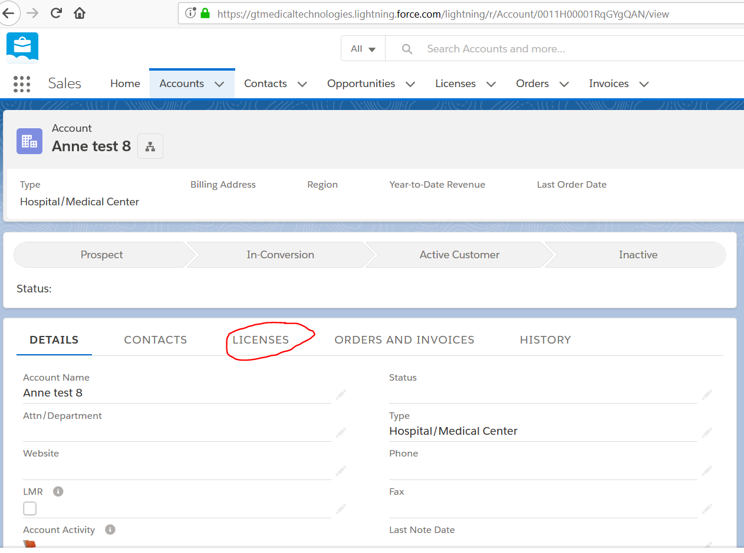

**Click New to add a new license record:**

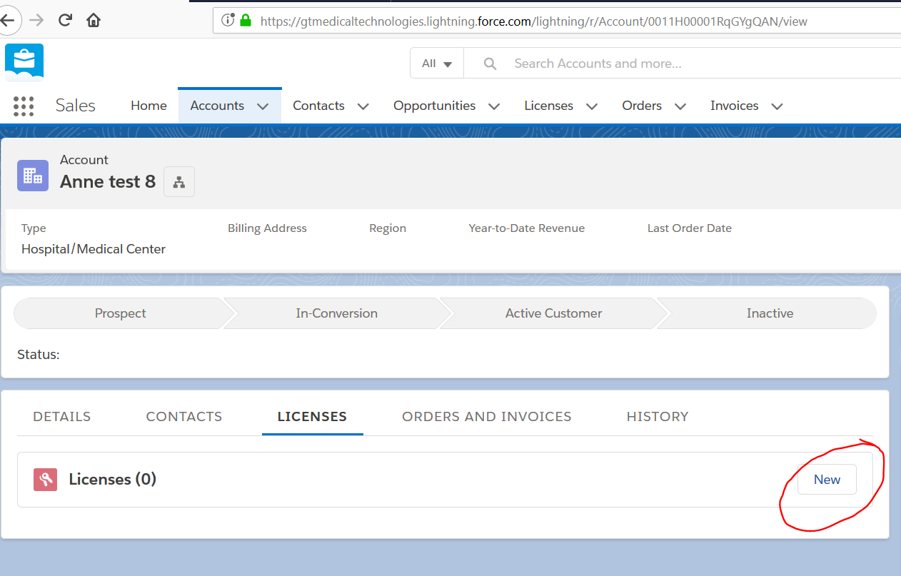

**Enter all applicable license data and click Save:**

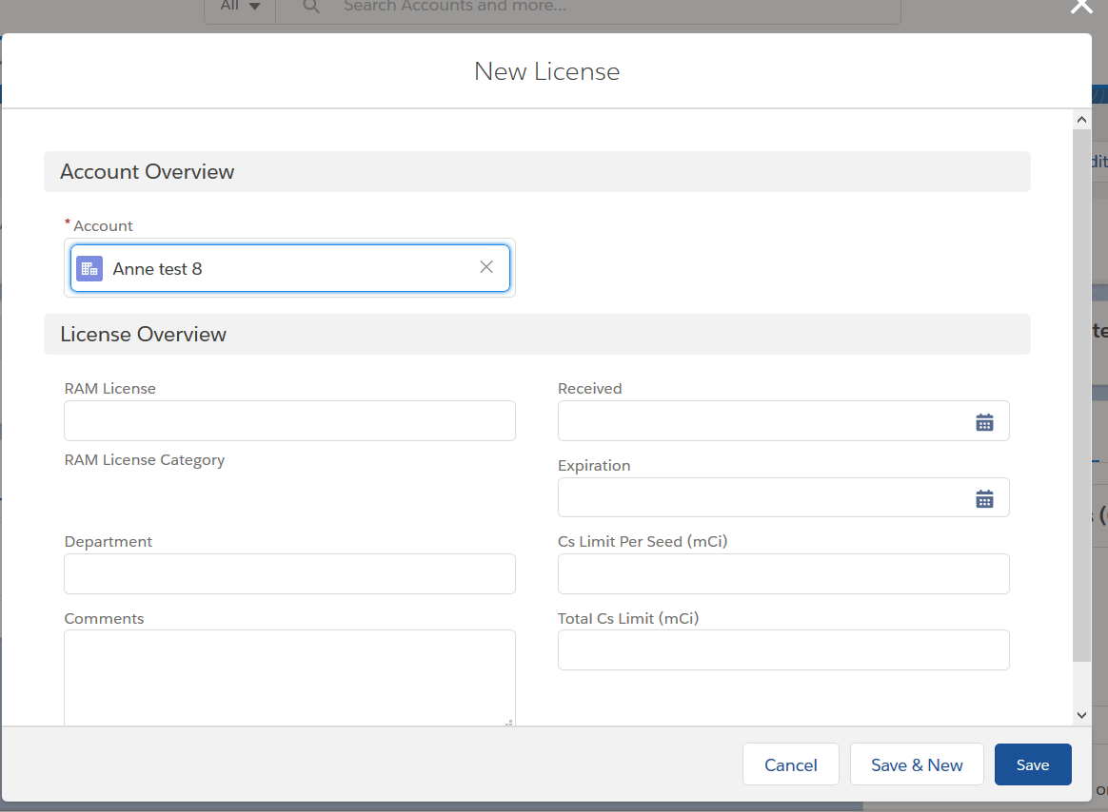

* + 1. **Data Review**

**On the account main page, review uploaded files and entered contract pricing, if applicable.**

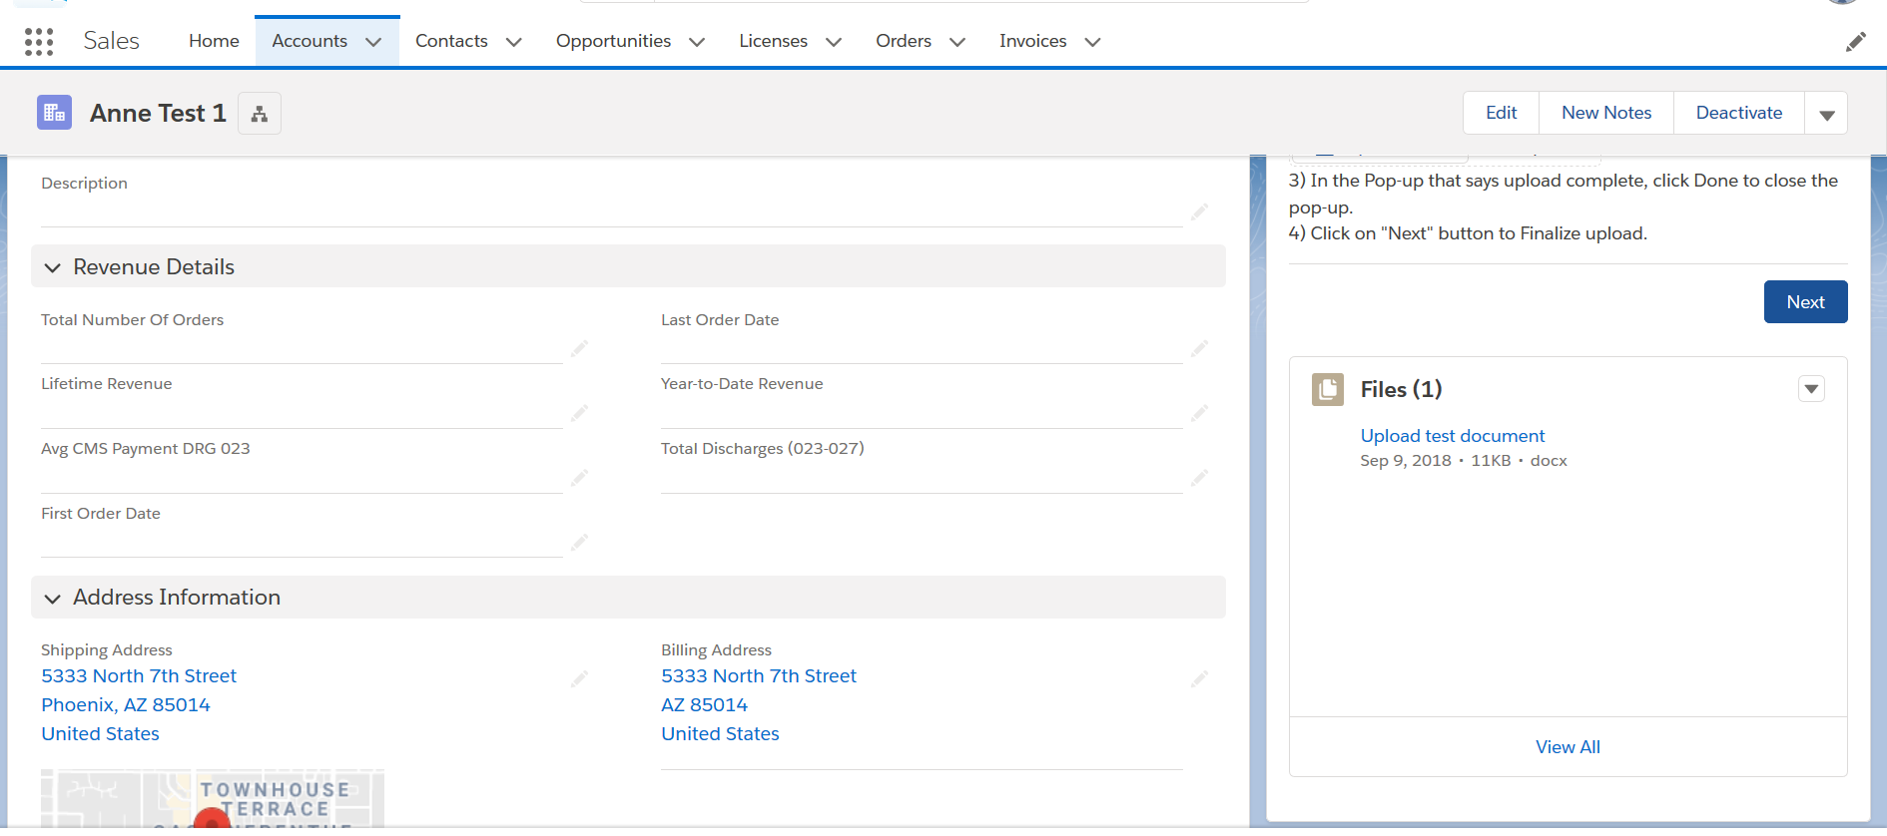

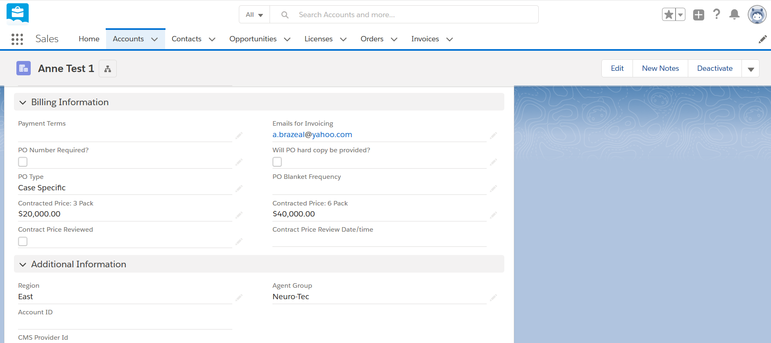

**If files are complete and accurate and pricing meets sales floor requirements, check appropriate review boxes and change status to “GTMT Internal Review Complete”. Salesforce will date stamp review fields when form is saved.**

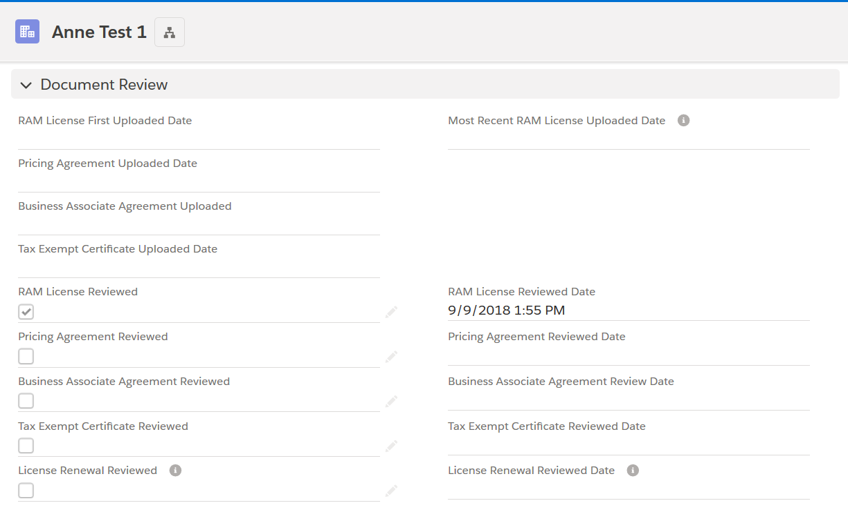



* 1. **Account Edit**

**To edit account data, find the Account using the search function and click Edit. Make changes and click Save.**

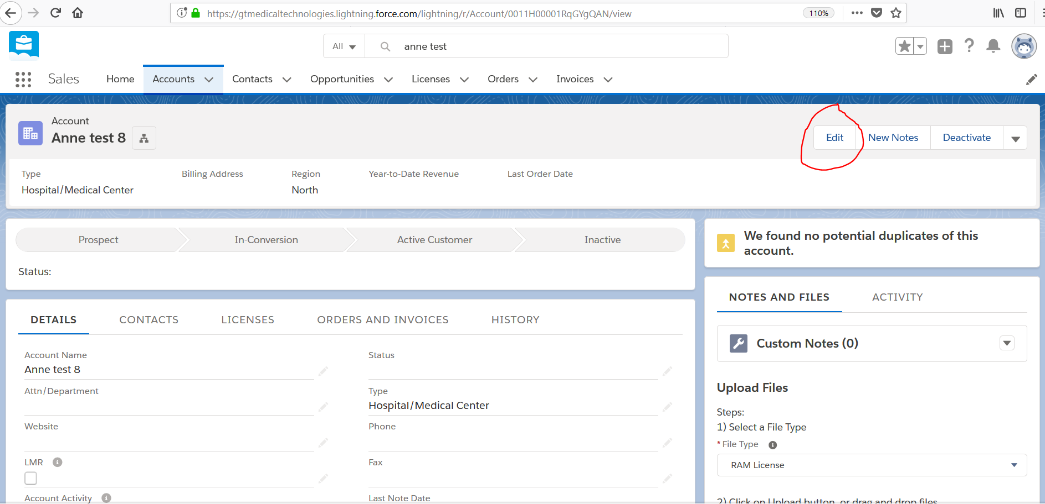

* 1. **New Contact**

**To add a contact, search for and select the Account and click on the Contacts tab:**

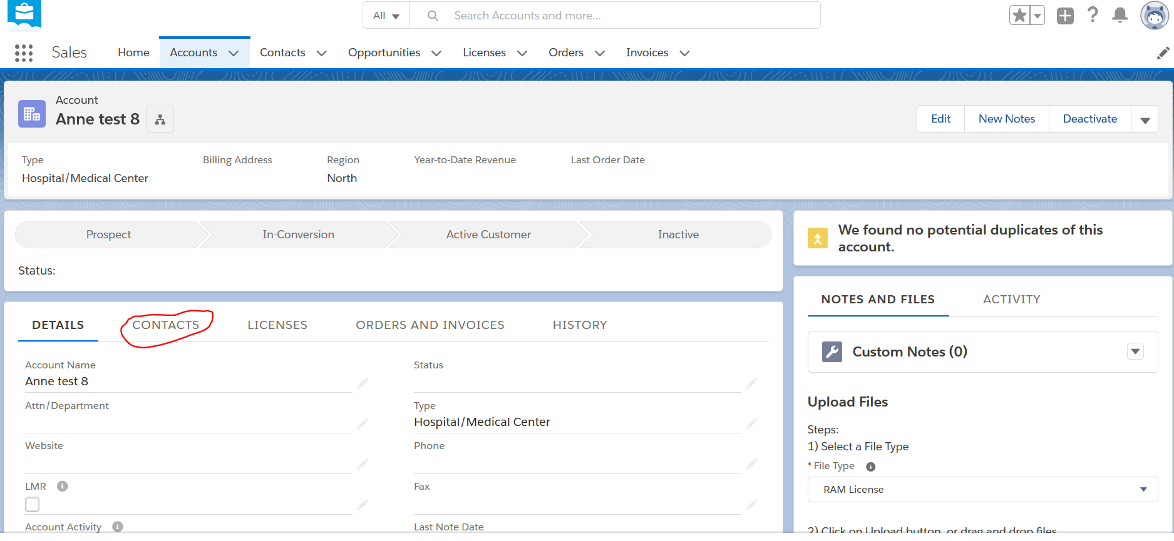

**Click New Contact, enter all applicable data and click Save:**

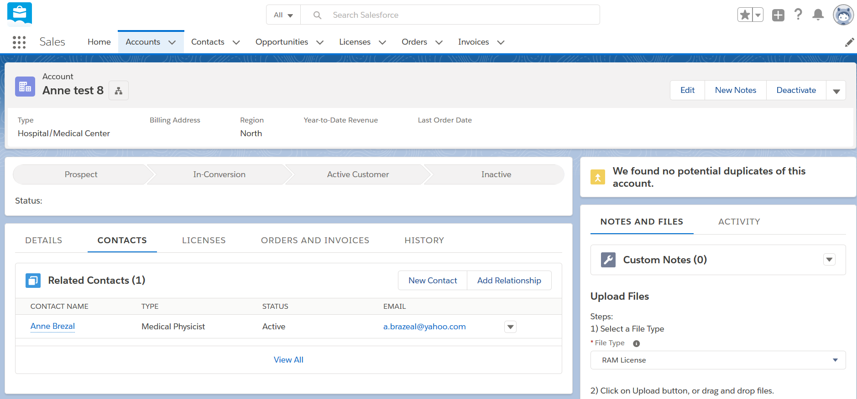

* 1. **Edit Contact**

**To Edit a Contact, search for the contact. Click Edit, update information as applicable and click Save.**

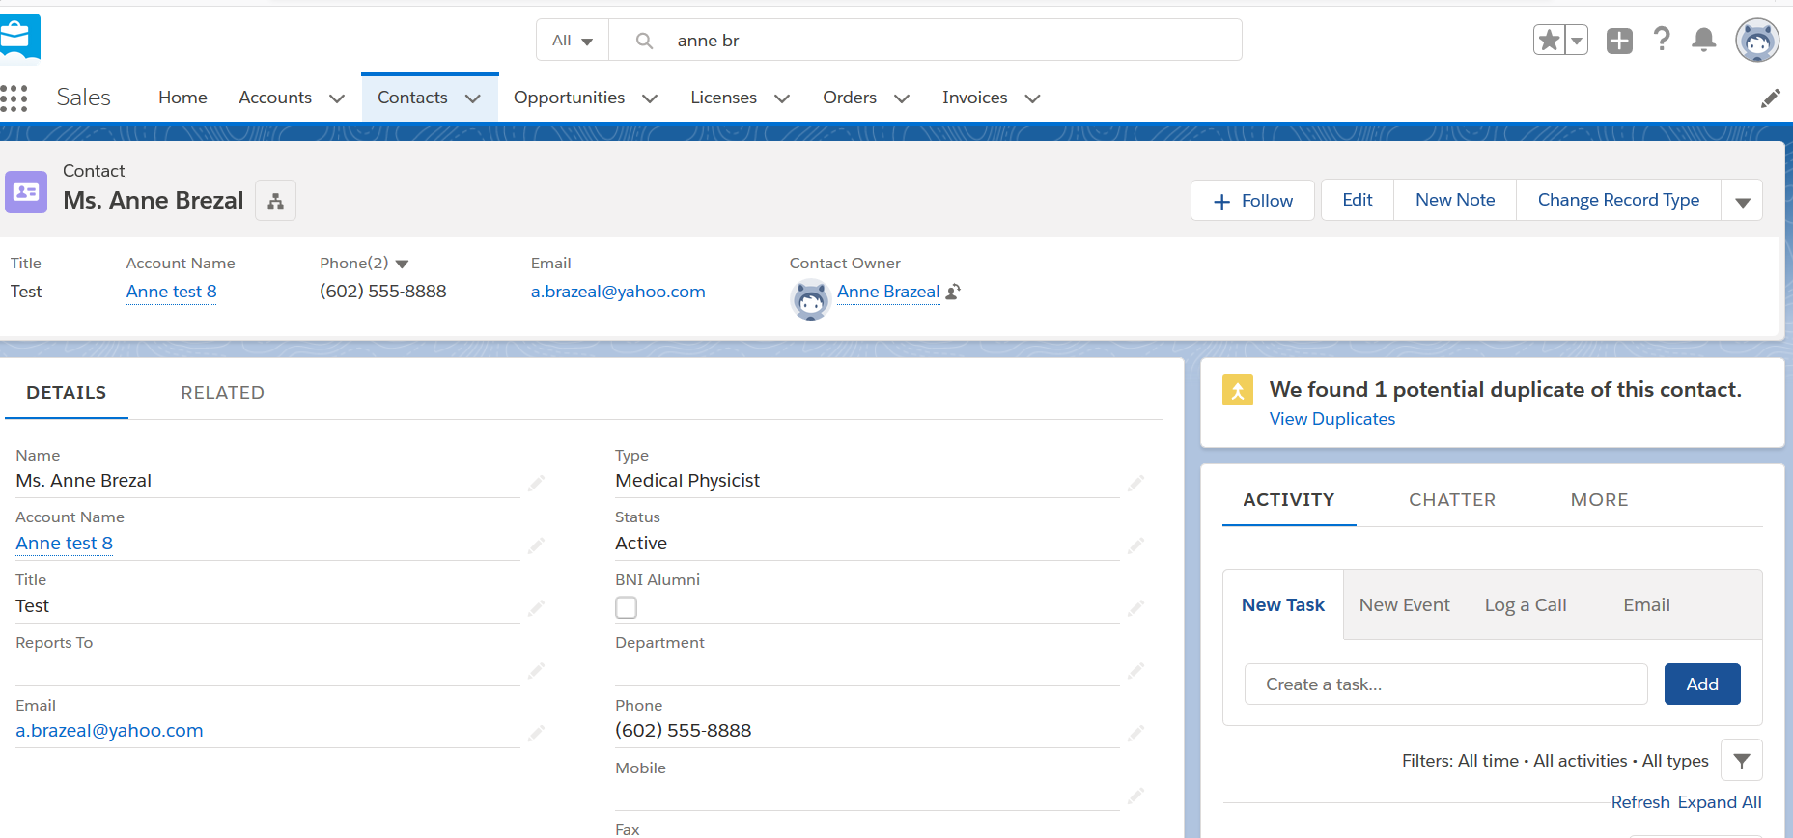

1. **Orders**
   1. **New Order Review/Status Change**

**Click on the link in the order email or search for the Order using the Search functionality or click on the order tab to identify the order:**

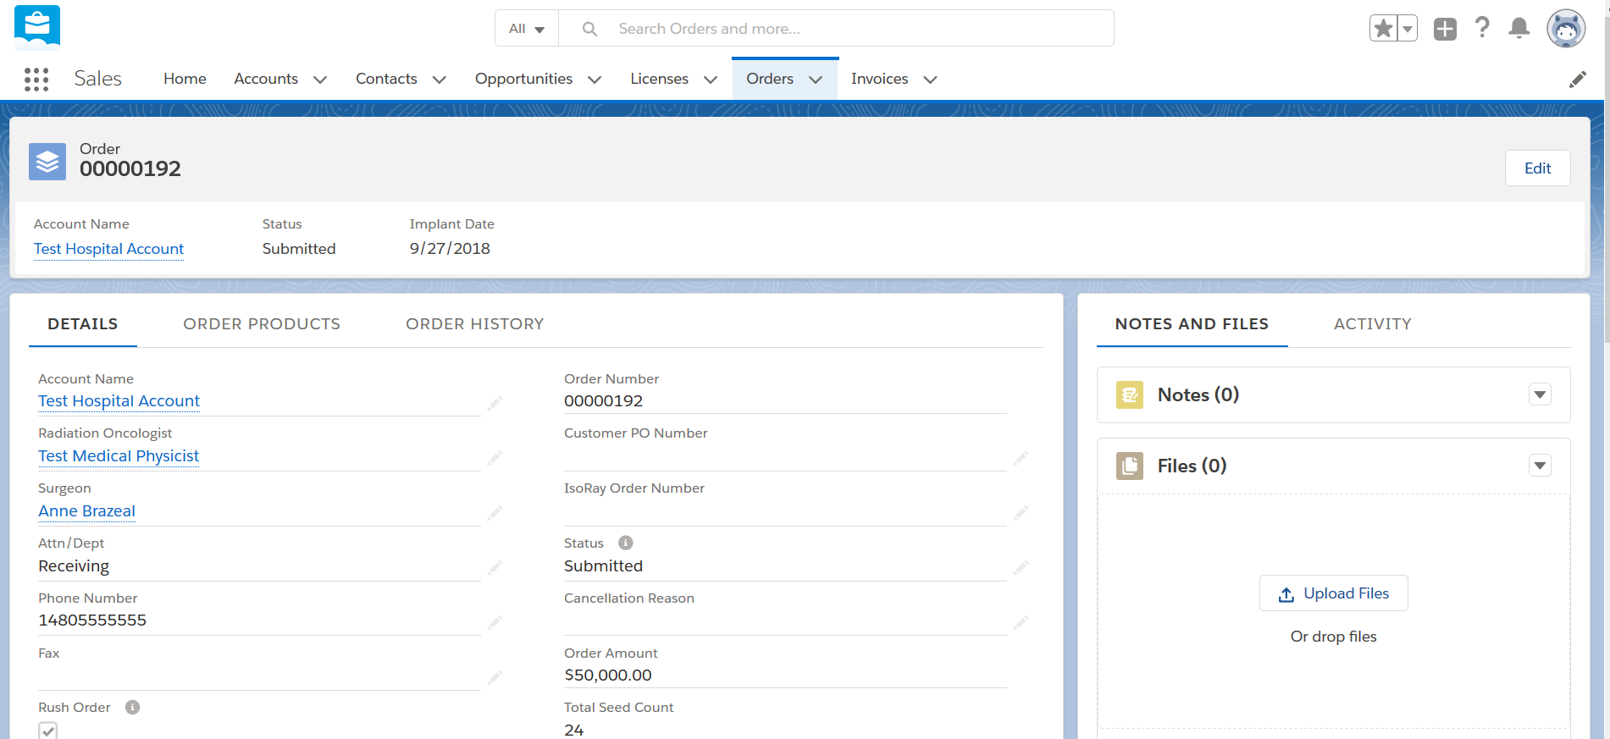

**Review order details including products ordered, requested delivery date, implant date and other order data. Contact Customer for clarity, as needed. If order data seems appropriate, click Edit and change status to “Order Accepted.”**



* 1. **GTMT Internal Review**

**If scheduled delivery date is greater than expected delivery date, order status is changed to GTMT Internal Review. Click on the link in the Order Status email or search for the Order using the Search functionality or click on the order tab to identify the order. Contact Customer about date change. If order is accepted by Customer, click Edit and change status to “Sterilized.” If order is not accepted by Customer, click Edit and change status to “Cancellation – Before Delivery” and update reason code to “Late Delivery”.**



* 1. **Order Edit**

**To edit order details prior to Vendor Confirmed status, click on the link in the order email or search for the Order using the Search functionality or click on the order tab to identify the order and click Edit:**



**To edit or add products, click on the Order Products tab:**

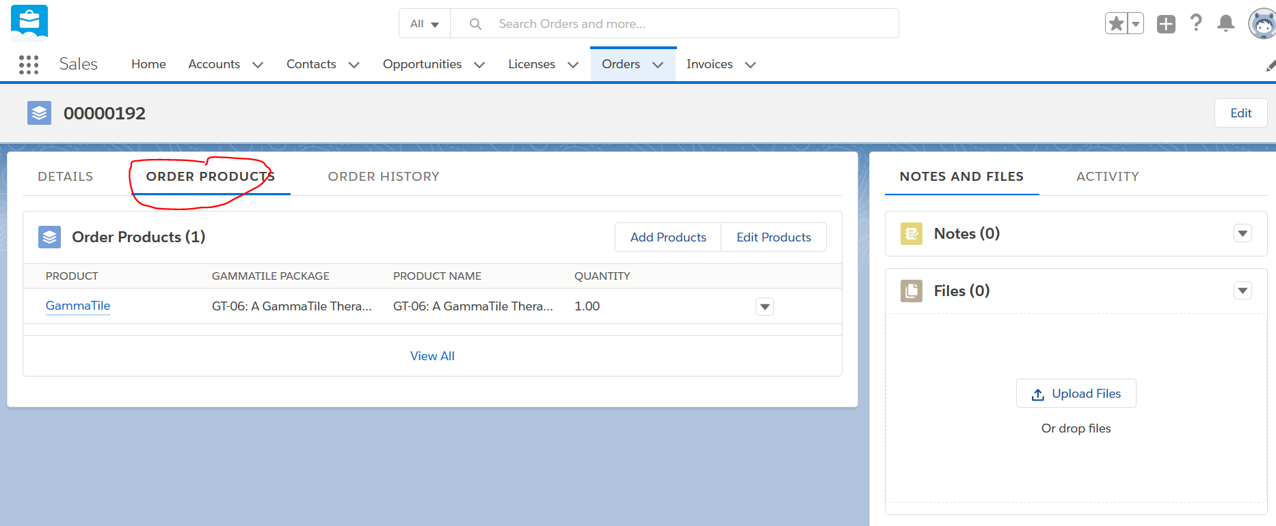

**To Add Products, click Add Products, click the plus sign next to GammaTile and click Next:**

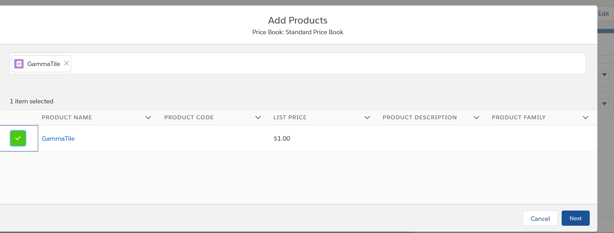

**Click in the “GammaTile Package” box to choose the product from the drop down, leave Loose Seeds and Unit Price at default of 1, enter order quantity and click Save:**

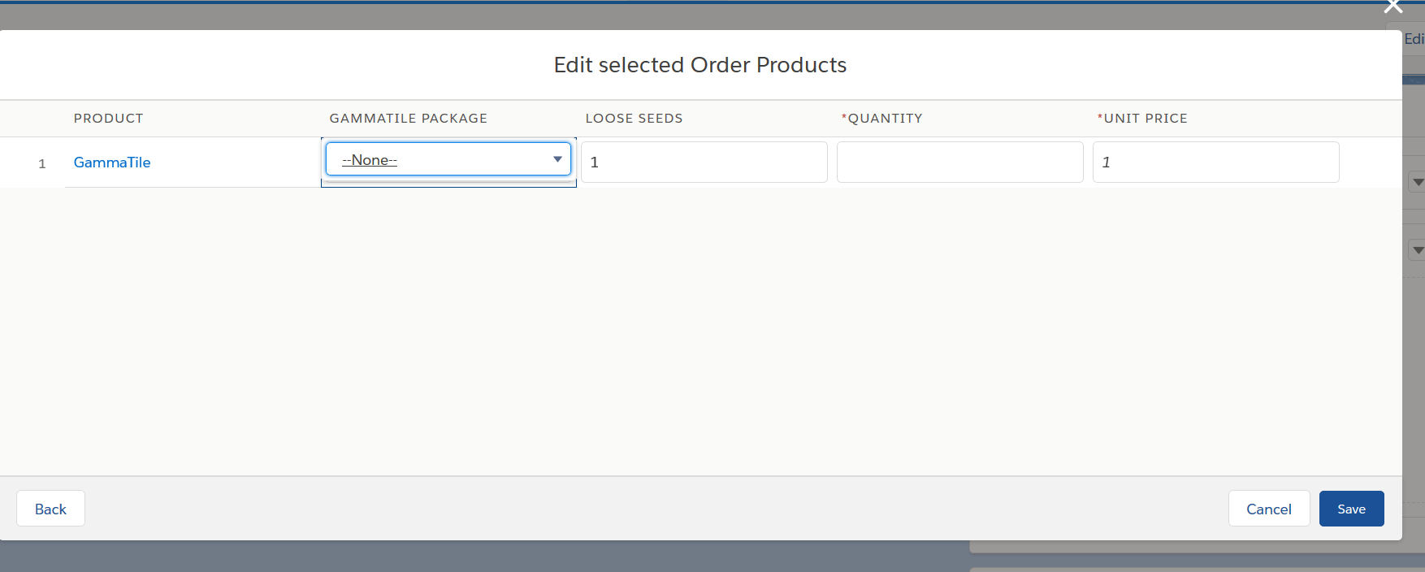

**To Edit Products, click Edit Product, update product quantity and click Save:**

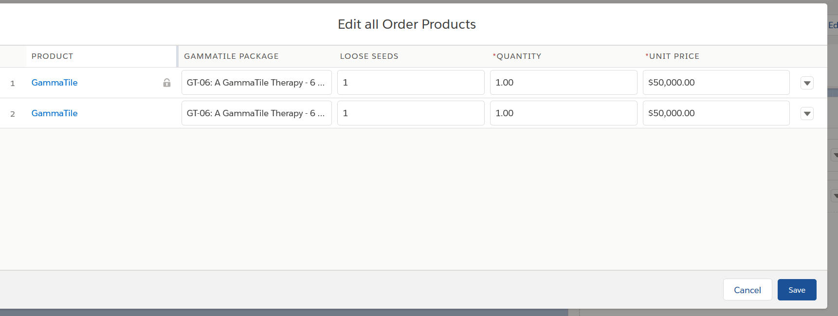

**To Delete a product, click the arrow next to the product and select delete:**

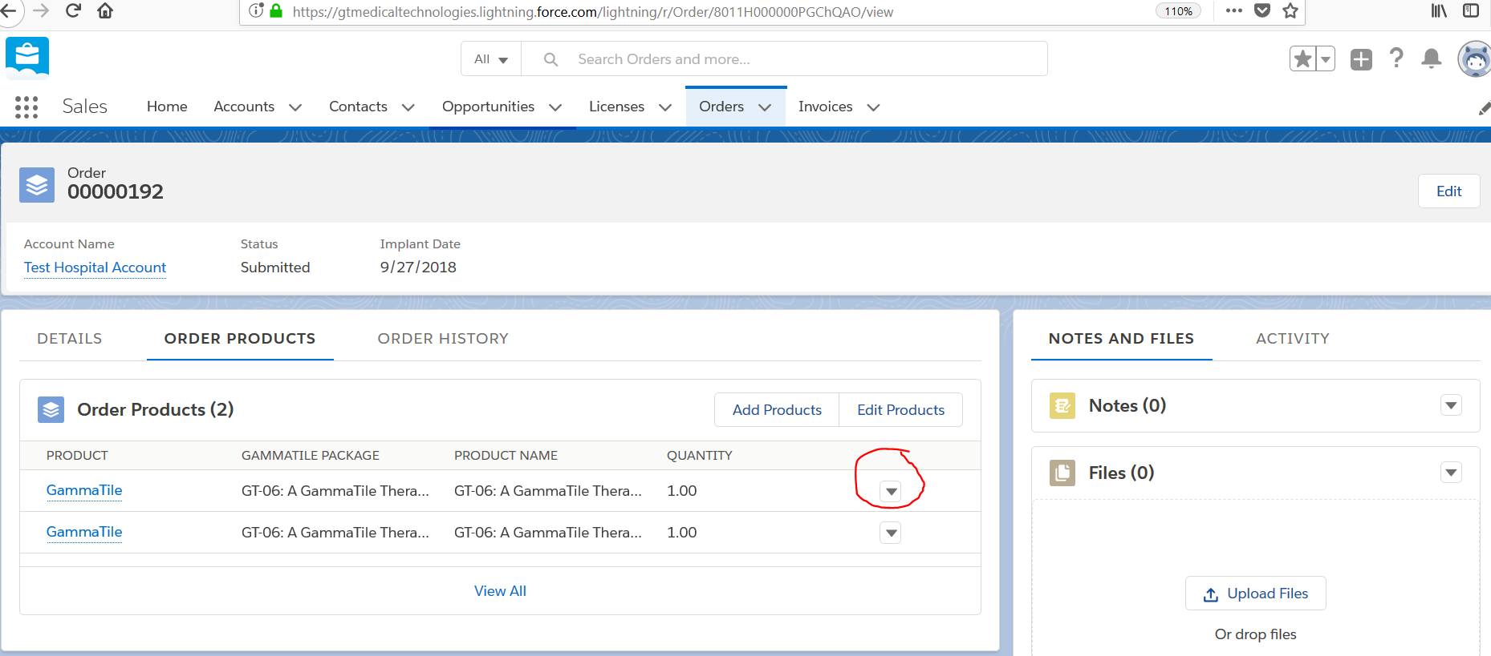

* 1. **Order Cancellation**

**Click on the link in the order email or search for the Order using the Search functionality or click on the order tab to identify the order. Click Edit, update the Status to “Cancelled – before delivery” or “Cancelled – after delivery”, update the reason code and click Save.**



**APPENDIX E – Salesforce New User Instructions**

Users in Salesforce can be Setup by either a System Administrator or a GT Med Tech Super User.

New Internal User Setup

Step 1: Click on the Gear Icon on the top right corner of the screen and click on ‘Setup’.

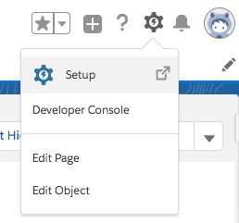

Step 2: Type in “Users”, in the quick find toolbar, and select “Users”

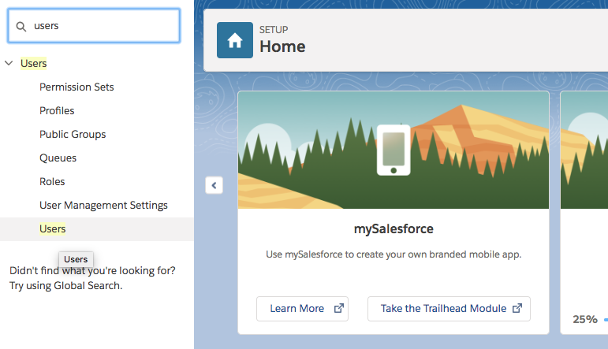

Step 3: Click on ‘New User’ button

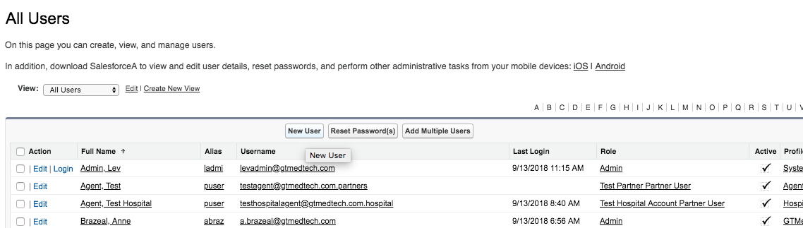

Step 4: Fill in the user info.

PS: The username is automatically filled in based on the email address.

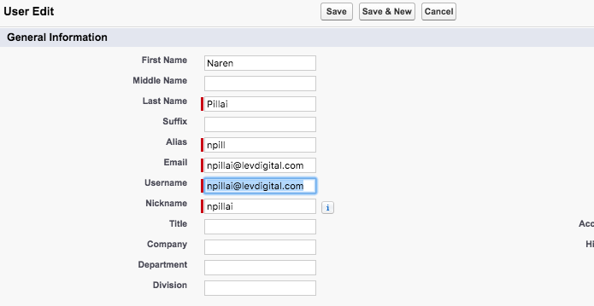

Step 5: Set the User license as “**Salesforce**”.

Role: Set the Role as “**Executive**” for standard users, and “**Admin**” for admins and super users;

Profile: Set the profile based on the level of access needed for the user. The following profiles are configured for GT Medtech. Please set one of the following three options for the profiles based on the access required for the user.

* **System Administrator**: Provides admin level privileges.
* **GTMedTech Super User:** Provides user with access to create new users, override some functionality, like editing an order form after certain stages, and delete records.
* **GTMedTech Standard User:** No access to modify orders, after the order status is set to Vendor Confirmed status. No access to setup. No access to manage users. No Delete access to any objects used.

Apart from these three profiles, you will still see a few other profiles that comes out-of-the-box with salesforce. Please do not use any profile other than the three mentioned above, as the system might not work as expected.

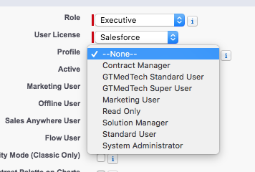

Step 6: Ensure the “**Flow User**” checkbox is selected. Flow user is required to see the the custom ‘File Upload’ component and run a few automations in the backend.

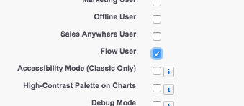

Step 7: Leave the other settings as default

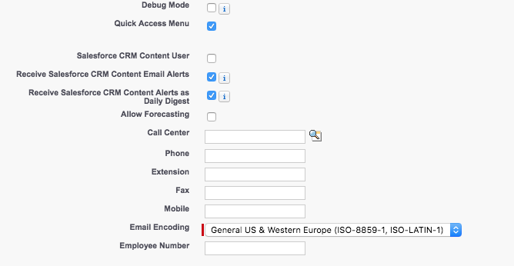

Step 8:

* Set Time zone relevant to the user. Use **GMT-07:00 Mountain Standard Time (America/Phoenix)** if the user is based out of Arizona.
* Set Locale to **English (United States).** Locale defines the currency, date/time format etc. that are displayed for a user. For e.g. English (United States) will display the currency in Order Amount in US $, and date/time format as mm/dd/yyyy, whereas English (United Kingdom) will display currency in Pounds, and date/time format as dd/mm/yyyy.
* Set Language as **English**

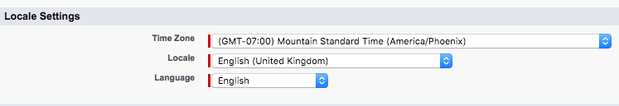

Step 9: Ensure that the ‘Generate new password and notify user immediately’ checkbox is selected. When this is selected, salesforce sends the user with a link in the email to log into salesforce and setup a new password.

Step 10: Click Save.

New Community User Setup

At a high level, these 3 steps are needed to setup a community user

1. Account: To setup a community user, setup the Partner (Agent/ Hospital/ Isoray) account and enable them as a partner.
2. Contact: Create a new contact, if needed, and associate it with the partner account, and then enable them as a partner user.
3. Enabling the contact as a partner user will bring up the user setup screen where user specific details, like Profile are entered.

Step 1: Create an Account for the Partner (Agent/Hospital/Isoray), if it doesn’t exist.

Step 2: Go to the Account page, click on the dropdown button, and select “Enable as Partner”

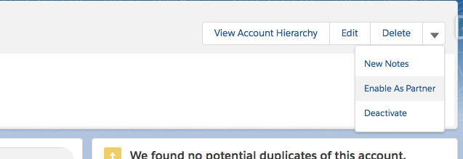

Step 3: Click on “Enable as Partner” on the pop-up window.

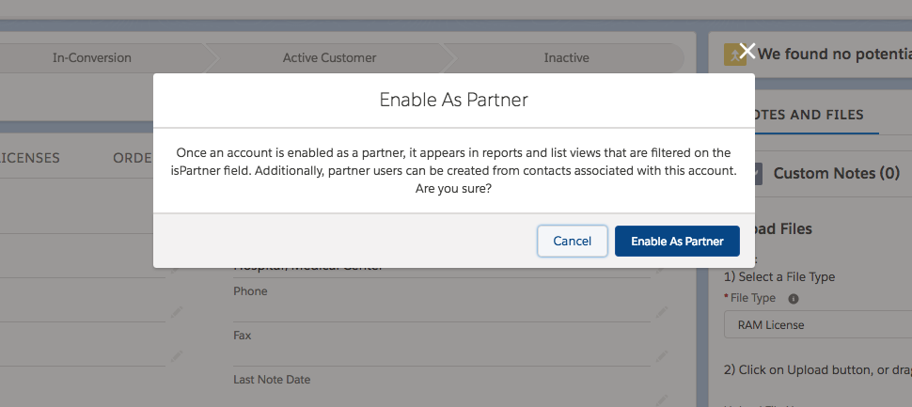

Step 4: Go to the “Contacts” section in the account page and click on the contact record that needs to be enabled as a user. If it doesn’t exist, create a new contact record.

Step 5: Click on the drop-down button, and select “Enable as Partner User”

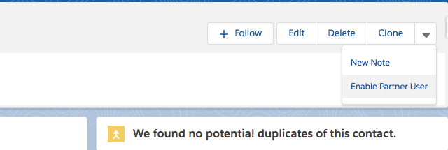

Step 6: This will navigate to the user setup screen, which will be pre-populated with the data from the contact record.

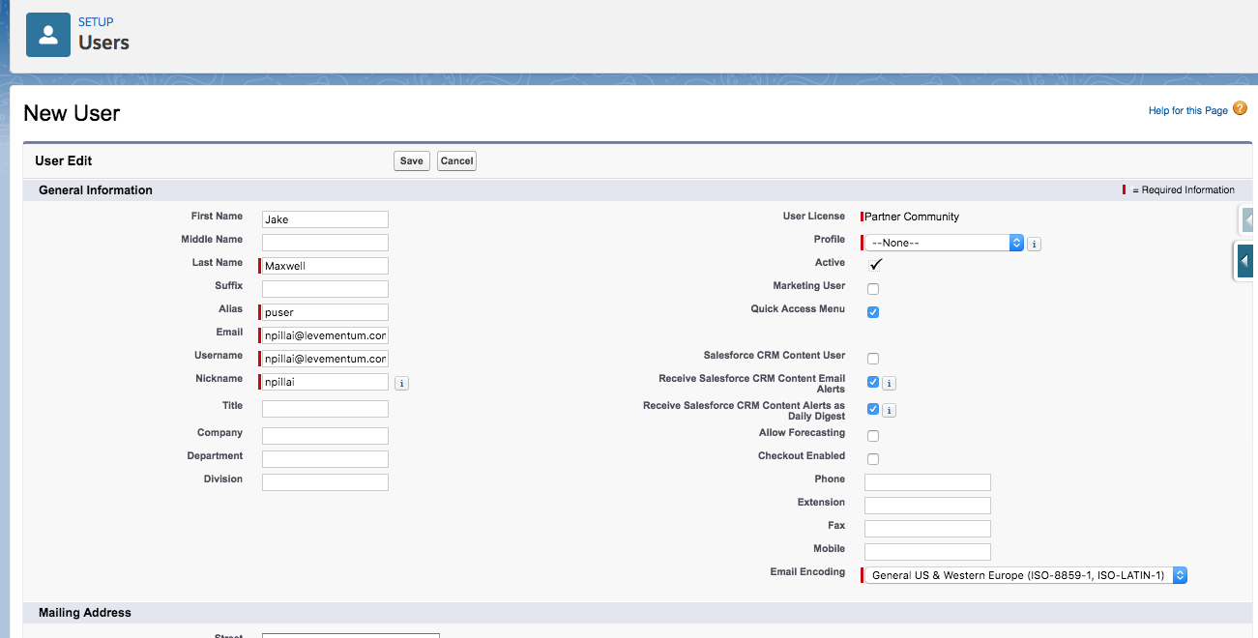

Step 7: Set the profile based on the type of community that the user needs access to.

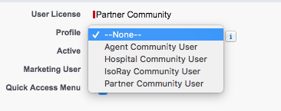

* Agent Community User: Provides access to the agent community
* Hospital Community User: Provides access to the Order Community, with the settings/ configurations required for Hospital users.
* IsoRay Community User: Provides access to the Order community, with the settings/ configurations required for the IsoRay user.

Use only the 3 profiles mentioned above. Any other profile will not give correct access to the community for the user.

Step 8: Click “Save”.

Step 9: If the user is ‘Agent’ community user, or ‘Hospital’ community user, then perform this additional step.

Go to Setup -> Users -> Public groups

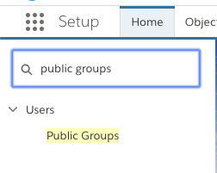

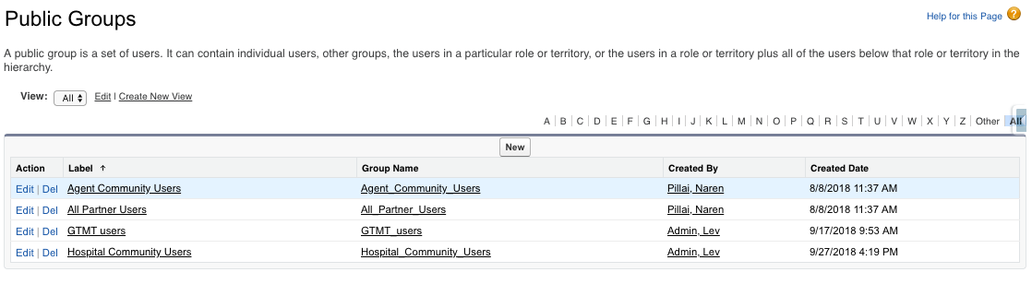

If the new user created is for ‘Hospital community, click ‘Edit’ link on the ‘Hospital Community Users’.

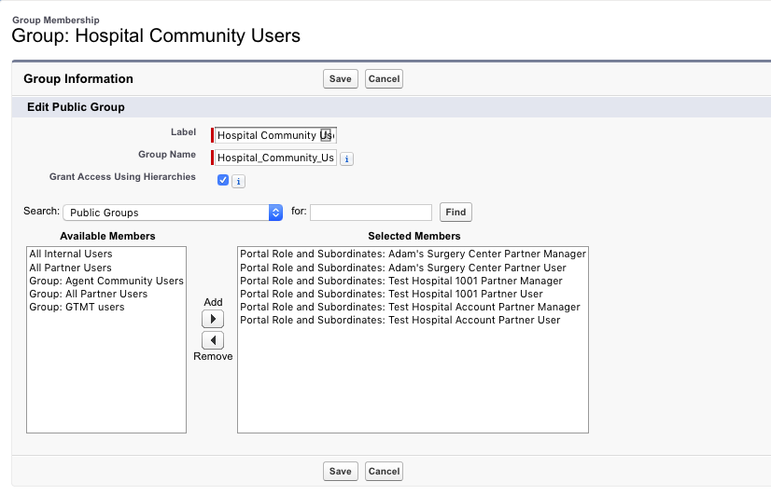

Click the drop-down on ‘Search’, and select ‘Portal Roles and Subordinates’

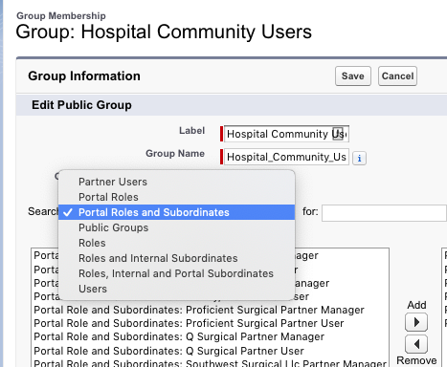

We typically see 2 roles with the user’s account name- for e.g. for the account ‘Test Hospital Account’. We see ‘Test Hospital Account Partner Manager’, and ‘Test Hospital Account Partner User’. Add both to the ‘Selected Members’.

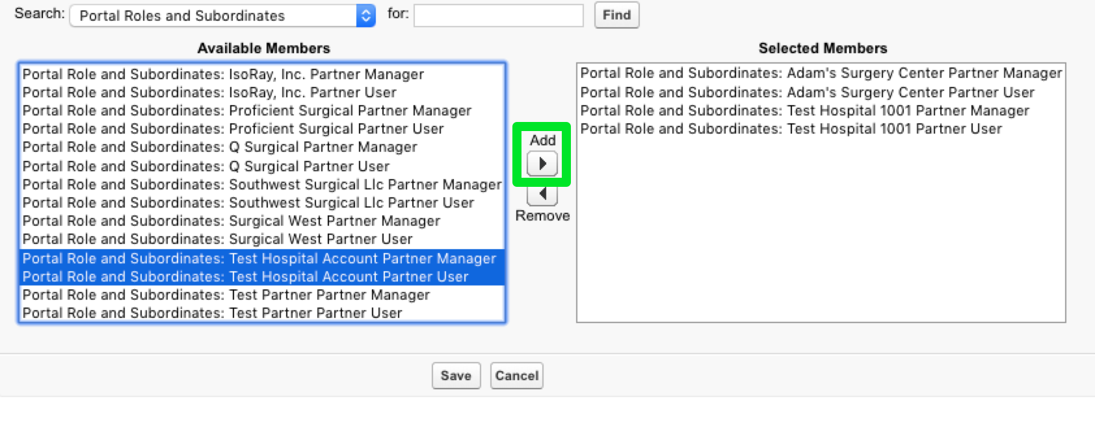

Click ‘Save’

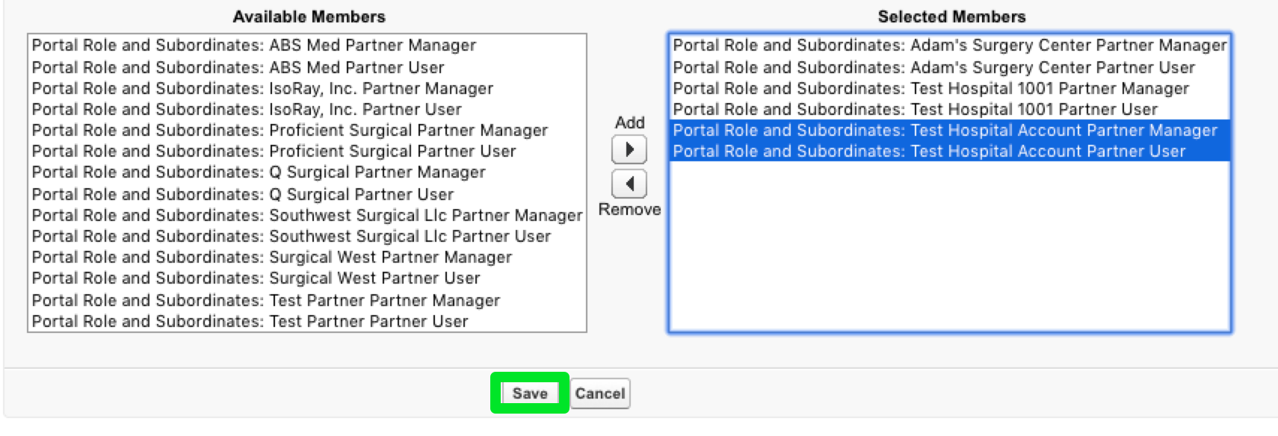

If the new user created is for ‘Agent Community’, click ‘Edit’ link on ‘Agent Community Users’, and add the ‘Portal Manager’ and ‘Portal User’ role that matches the ‘Account’ name of the community user.

If the new user created is for “Isoray community, click ‘Edit’ link on the ‘Isoray Community Users’, and add the ‘Portal Manager’ and ‘Portal User’ role that matches the ‘Account’ name of the community user.

Editing User Access

Admin users (users with ‘System Administrator’ profile, or ‘GT MedTech Super User’ profile) can edit another user’s detail. To do this, open the user detail page: Setup -> Users-> Users: Select the user from the list view, and click on ‘Edit’.

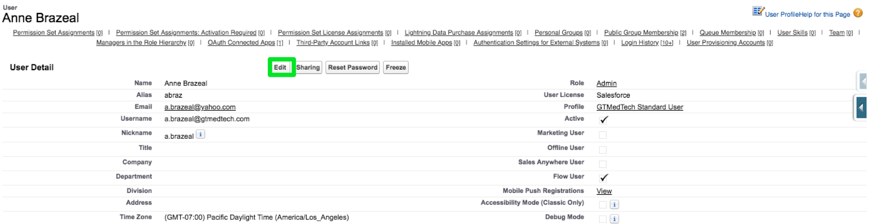

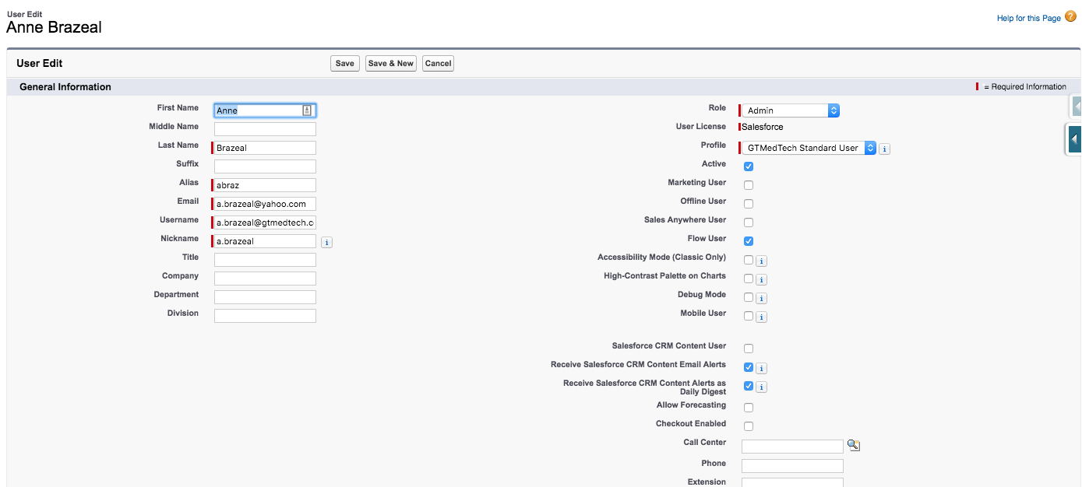

The admin user can edit the details like, role, profile, name, email etc.

PS: When the admin user updates the email address of a user, an email is sent to the updated email address for the user to confirm before the email address is updated.

When the admin user wants to update their own profile, all other details except the profile can be edited.

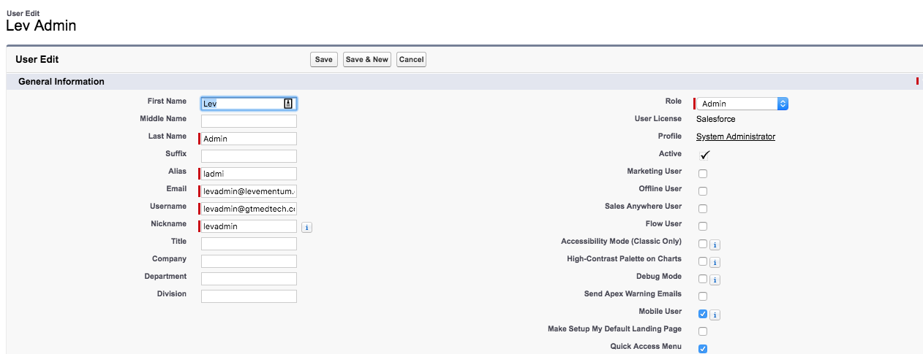

Password Resets

When a user forgets password, they can click on the ‘Forgot Your Password?’ link in the login screen.

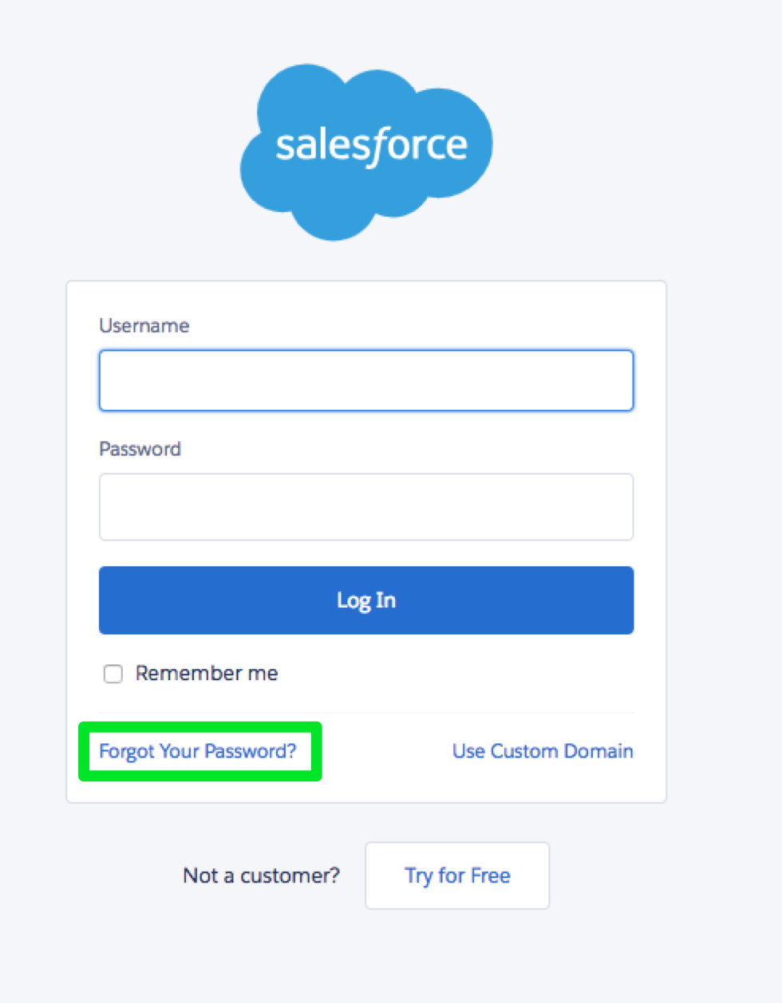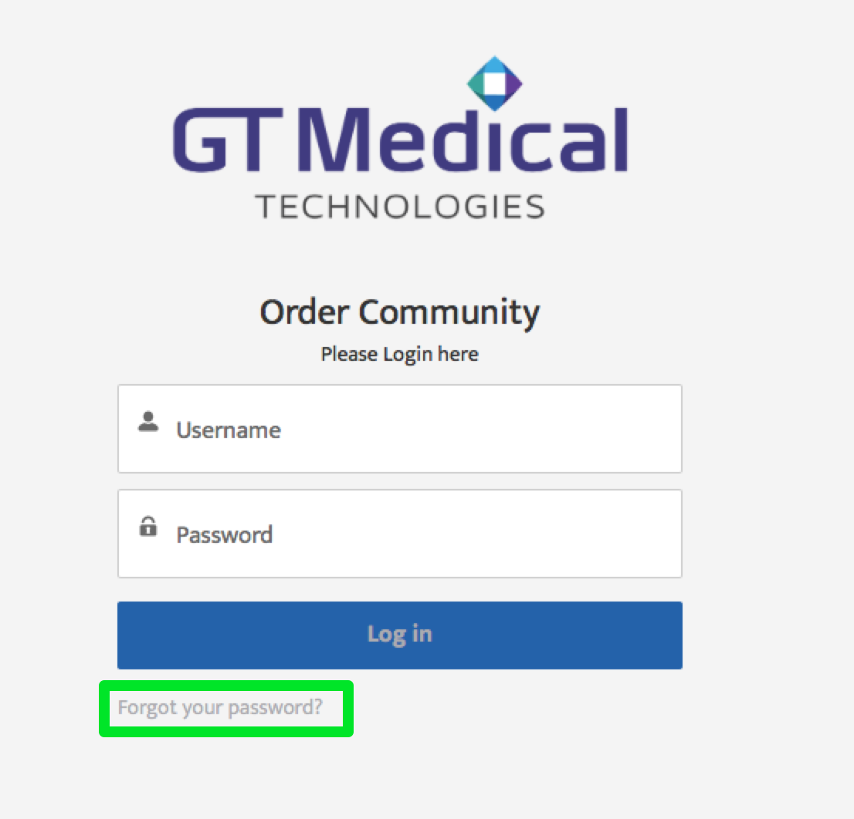

This will prompt the user to enter the ‘Username’ they use to log into salesforce to send the reset password link in an email.

If the user has reached out to the admin to reset password, the admin can go to the user record: Setup -> Users-> Users: Select the user from the list view.

In the User detail page, click on the ‘Reset Password’ link.

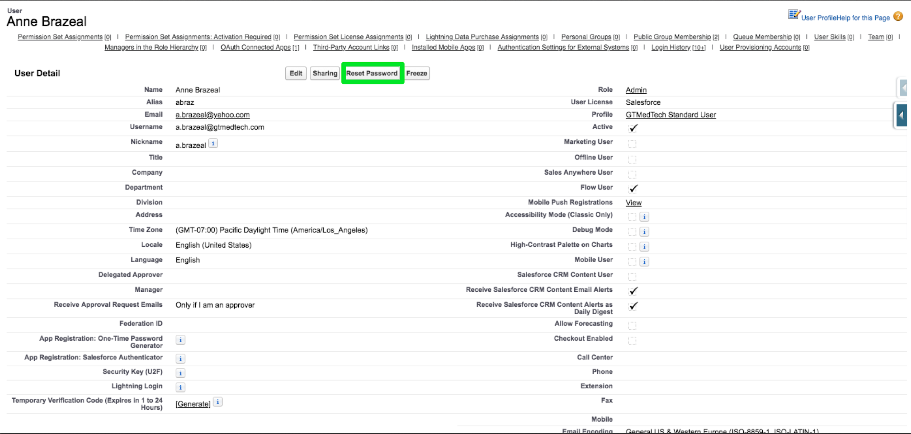

Typically, when the user clicks on ‘Forgot Password’, or when the admin uses the ‘Reset Password’ button, the email that gets sent to the user will have a link to reset password. Typically, when resetting password, salesforce asks for the challenge/ secret question that the user sets when setting the password for the first time.

In scenarios where the user doesn’t remember the secret answer to the question, there will need to be a hard reset of the password. Do this by opening the user detail page: Setup -> Users-> Users: Select the user from the list view and click on ‘Edit’.



Scroll down to the bottom of the screen and set the ‘Generate new password and notify user immediately’ checkbox to True. and click Save.

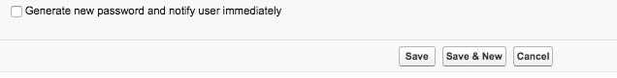

Deactivation/Freezing Users

* Deactivating Users

To deactivate a user, go to the user detail page: Setup -> Users-> Users: Click on the User from the List view. Click on ‘Edit’.

Uncheck the ‘Active’ Flag and click on Save.

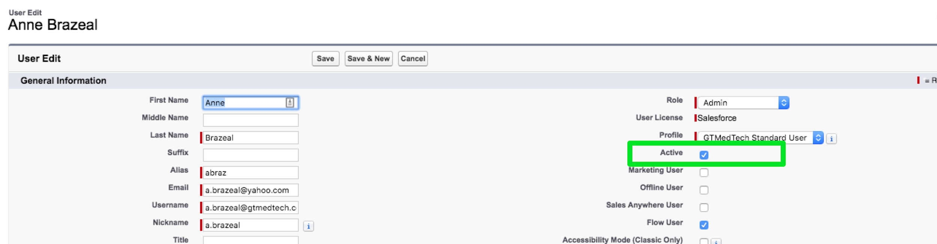

Deactivating a user will free up a user license that we can re-assign to other users.

* Freeze Users

The ‘Freeze’ option allows the admins to prevent users from logging into Salesforce, but doesn’t remove the license assigned to them

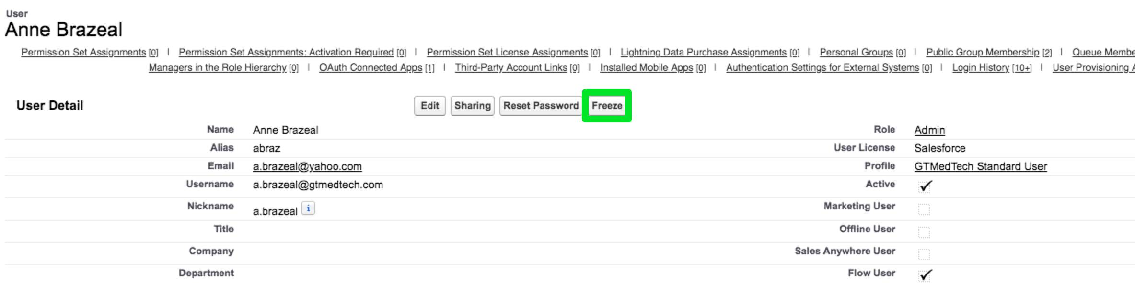

Freeze user option can be used in a few scenarios

* Temporarily block access to specific users to log into the system
* User cannot be deactivated immediately because of dependencies on the system (approval processes, default case owner etc.)